CMPSC 431W

Yuanpei Deng

Supplier:

In our case, supplier is the car seller. The attributes of supplier (dealer) are dealer name, address, phone number, type, and rating. The type attribute classifies supplier as car dealer and individual seller. The dealername here is used as the primary ID and required to be unique. Phone numbers, rating, type, etc are attributes connected to each dealer. The rating is a weighted score calculated by buyer’s (register user) rating on aspects like accuracy, price, choice, service, and feedback. Dealer will have an inventory. The relation is called owns and the entity is cars. The cars table is discussed in detail in the above sale items section. The dealer also has a relation named locates and the entity is address. The address we used here is zip code. Address is an important attribute in car shopping. People would prefer a dealer near their location so that they can go to store for a test drive and get car service there after the purchase. The address would be used in the search to decrease the scope. The reason we choose make “address” as an entity instead of an attribute is that we can use the similar schema for registered users. The ER diagram looks like this:

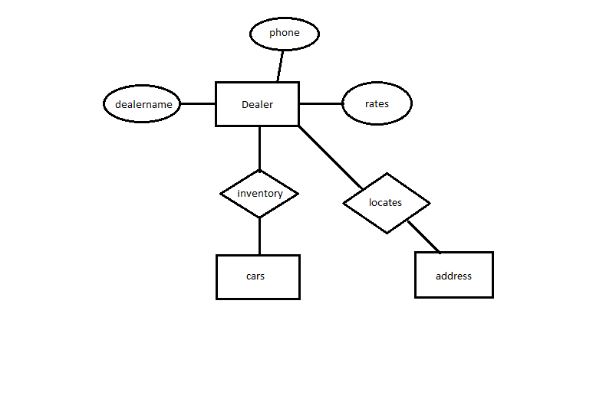

Registered Users:

The registered users are the buyers who can buy or bid on an item (car). Buyer must be registered, and identified by a user name and authenticated with a password. When registering, the user would be asked the following information in order to register successfully. These information includes: email address, name, address, phone number and credit card info like type of card, card number, cvv and expiration date. This picture shows how the interface of registering page look like. (In real design the credit card information will be added.)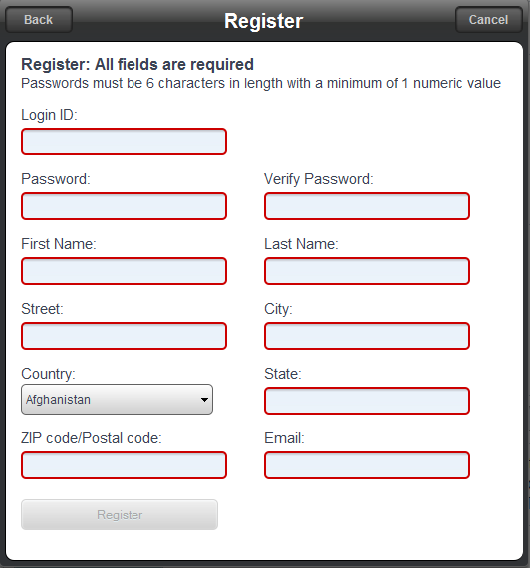

In addition, after registering a user can complete his or her whole profile by adding other information like age, gender and annual income. These attributes can be NULL if the user chooses not to fill.

Register user also has a rating attribute. A new user has a rating of 0 to start with and recalculates his or her rating score after each successful business.

The ER diagram roughly looks like this:

